CSE 220 Data Structures - Quiz 01
A
Date: 26 February 2025
Time: 30 minutes

Name: ID:

- Draw the final Singly Linked List after performing the following sequence of operations. Assume that the initial list is: 15 → 25 → 30 → 40 [5 marks]
  - insert(index = 2, element = 45)
  - leftRotate(3)
  - remove(index = 3)
  - rightRotate(8)
  - leftRotate(5)
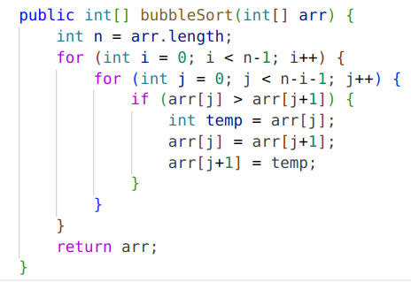
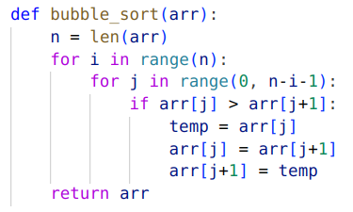
- Find the time and space complexity of the following code snippet: [5 marks]
Python Java
Write your answer below
Time complexity:
Space complexity:
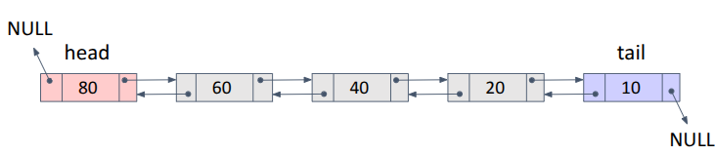
- You are given a doubly linked list, and your task is to insert a new node with the value 50 at index 2. The insertion should follow the correct sequence of operations. Below is a list of steps, but they are not in order. Rearrange them correctly to complete the insertion process. [5 marks]
  - Set newNode.prev = previous
  - Set previous.next = newNode
  - Set newNode.next.previous = newNode
  - Create a new node with the element 50
  - Find the previous node before the insertion position
  - Set newNode.next = previous.next

Write the correct sequence of operations (a,b,c,d,...) in the table below

1 | 2 | 3 | 4 | 5 | 6

Time complexity:

